**FOUNDATIONS OF STATISTICS: – ASSIGNMENT – 1**

**Name: SYED OMAIR MAQDOOM MOHIUDDIN ID: 102873768**

**QUESTION 1:**

The distribution of employee’s responses to the statement “I enjoy my work” for a random sample of 1500 Australian public sector employees is displayed in Figure 1. The majority employees agree that they enjoy their work [56.9%] followed by those who strongly agree [26.5%]. Whilst 10.8% reported that they neither agree nor disagree, 4.1% reported that they disagree and very few [1.7%] reported that they strongly disagree.

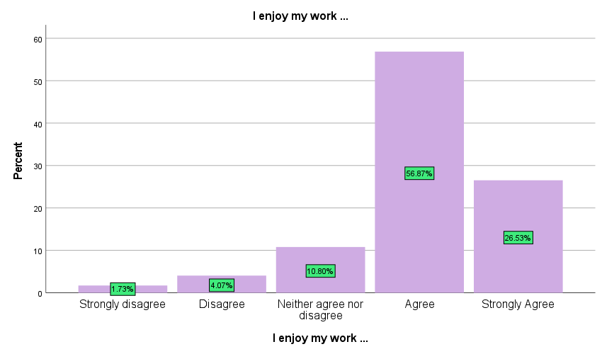

Figure 1: Distribution of responses of employees to the statement “I enjoy my work”

**Additional Output:**

|  |  |  |  |  |  |
| --- | --- | --- | --- | --- | --- |
| **I enjoy my work ...** | | | | | |
|  | | Frequency | Percent | Valid Percent | Cumulative Percent |
| Valid | Strongly disagree | 26 | 1.7 | 1.7 | 1.7 |
| Disagree | 61 | 4.1 | 4.1 | 5.8 |
| Neither agree nor disagree | 162 | 10.8 | 10.8 | 16.6 |
| Agree | 853 | 56.9 | 56.9 | 73.5 |
| Strongly Agree | 398 | 26.5 | 26.5 | 100.0 |
| Total | 1500 | 100.0 | 100.0 |  |

**QUESTION 2:**

The distribution of employee’s level of engagement with their job for a random sample of 1457 Australian public sector employees is displayed in Figure 2. The distribution is negatively skewed with 50% level of engagement of employees being 16.00 or less. Typically, level of engagement was between 13.00 and 18.00 with half of the level of engagement of employees with their job falling with this range. There were some extremely low levels of engagement of employees with their job below 1.00, with the lowest being 0.00. 10% of level of engagement was 9.00 or more, with the lowest being 0.00.

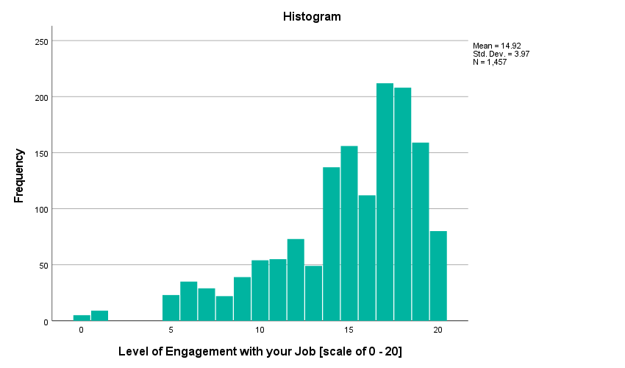

Figure 2: Distribution of Level of Engagement of Employees with their job

**Additional Output:**

|  |  |  |  |  |
| --- | --- | --- | --- | --- |
| **Descriptives** | | | | |
|  | | | Statistic | Std. Error |
| Level of Engagement with your Job [scale of 0 - 20] | Mean | | 14.92 | .104 |
| 95% Confidence Interval for Mean | Lower Bound | 14.72 |  |
| Upper Bound | 15.13 |  |
| 5% Trimmed Mean | | 15.21 |  |
| Median | | 16.00 |  |
| Variance | | 15.762 |  |
| Std. Deviation | | 3.970 |  |
| Minimum | | 0 |  |
| Maximum | | 20 |  |
| Range | | 20 |  |
| Interquartile Range | | 5 |  |
| Skewness | | -1.107 | .064 |
| Kurtosis | | .919 | .128 |

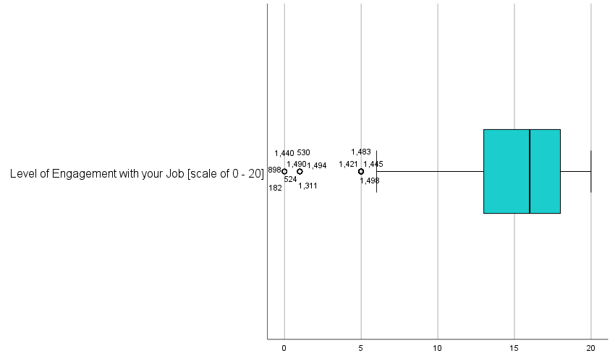

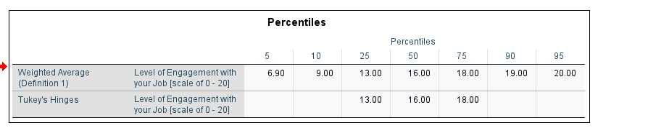

**Question 3:**

The distribution of level of engagement of employees with their Agency/Department for a random sample of 1496 Australian public sector employees is displayed in Figure 3. The distribution is approximately symmetric, with the average level of engagement being 8.38 (s = 3.04). Typically, the average level of engagement was between 6.00 and 11.00, with half of the level of level of engagement falling within this range.

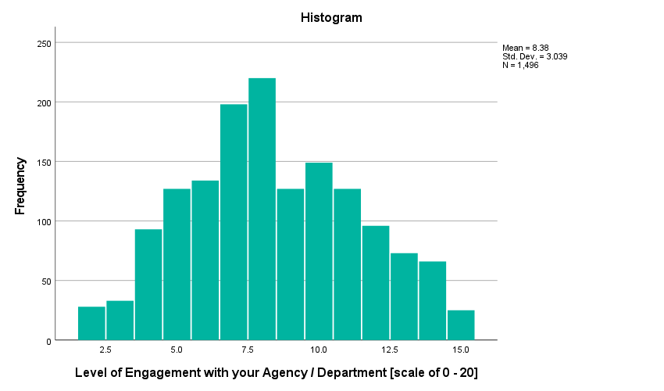

Figure 3: Distribution of level of Engagement of employees with their Agency/department

**Additional Output:**

|  |  |  |  |  |
| --- | --- | --- | --- | --- |
| **Descriptives** | | | | |
|  | | | Statistic | Std. Error |
| Level of Engagement with your Agency / Department [scale of 0 - 20] | Mean | | 8.38 | .079 |
| 95% Confidence Interval for Mean | Lower Bound | 8.23 |  |
| Upper Bound | 8.54 |  |
| 5% Trimmed Mean | | 8.36 |  |
| Median | | 8.00 |  |
| Variance | | 9.235 |  |
| Std. Deviation | | 3.039 |  |
| Minimum | | 2 |  |
| Maximum | | 15 |  |
| Range | | 13 |  |
| Interquartile Range | | 5 |  |
| Skewness | | .144 | .063 |
| Kurtosis | | -.640 | .126 |

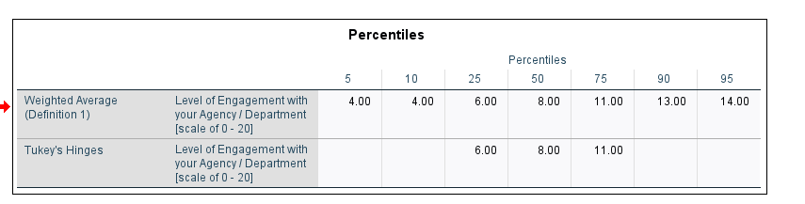

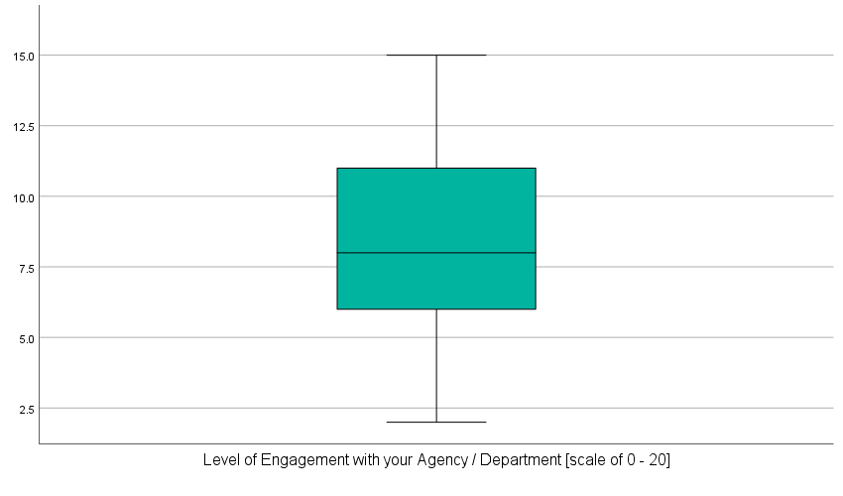

**QUESTION 4:**

To find that if john is unusually slow compared to other posties in the following routes, we need to find out z score for each route.

**Z = Data value – Mean / standard deviation**

**Route 1**

Given Mean = 60 minutes and Standard deviation = 20

So, z score = 110 – 60 / 20 = 2.5

Z score = 2.5

For this distribution, a test score of 110 is an unusual/unlikely, score. It sits more than 2 standard deviations above the mean.

**James would be considered unlikely slow when compared with other posties on this route.**

**Route 2**

Given Mean = 120 minutes and Standard deviation = 10

So, z score = 110 – 120 / 10 = -1

Z score = -1

For this distribution, a test score of 110 is not an unusual/unlikely, score. It sits within 2 standard deviations of the mean.

**James would not be considered unusually slow when compared with other posties on this route.**

**Route 3**

Given Mean = 100 minutes and Standard deviation = 10

So, z score = 110 – 100 / 10 = 1

Z score = 1

For this distribution, a test score of 110 is not an unusual/unlikely, score. It sits within 2 standard deviations of the mean.

**James would not be considered unusually slow when compared with other posties on this route.**

**Route 4**

Given Mean = 140 minutes and Standard deviation = 15

So, z score = 110 – 140 / 15 = -2.0

Z score = -2.0

For this distribution, a test score of 110 is not an unusual/unlikely, score. It sits within 2 standard deviations of the mean.

**James would not be considered unusually slow when compared with other posties on this route. Although, he would be considered faster when compared to other posties on this route.**

**QUESTION 5:**

a.

The population that we draw conclusion about in this study is the mid-sized tinned nectarines produced by the Tinned Fruit company in the month of July. It is because the consumer organisation randomly selected 1500 tins of nectarines produced in July by Tinned Fruit company and recorded the weight of these tins.

b.

The highlighted section represents the frequency of the sample size of 1500 where the average[mean] IQ was 199.5, where the frequency was 15.

c.

It is unusual/unlikely that it belongs to the sampling distribution. The mean of our sample was more than 2 standard errors above the mean of the sampling distribution of sample means, it falls in the critical/unlikely region. It has a standard error of 2.6 [rounded to two digits], which is more than 1.96.

d.

Based on the above discussion we can conclude that the mean weight of the tins containing nectarines is now greater than 200g.